Chapter 13, Problem 44.

In the ideal transformer circuit of Fig. 13.108, find i₁(t) and i₂(t).

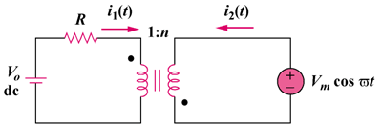

Figure 13.108
For Prob. 13.44.

